**Michael Echols, Chair**

Monroe

**Rex Alexander**

Lake Charles

**Marguerite Anderson**

West Monroe

**Waynette Ballengee**

Shreveport

**Pamela Breaux**

Lake Charles

**Dwayne Carruth**

Baton Rouge

**Missy Crews**

Baton Rouge

**Gena Gore**

Dry Prong

**Gerri Hobdy**

Baton Rouge

**Mary Lee**

Mandeville

**George Marks**

Arnaudville

**Barbara Motley**

New Orleans

**Patti Nelson**

Monroe

**Sheela Plater**

Thibodaux

**Michael D. Robinson**

Baton Rouge

**Jacques Rodrigue**

New Orleans

**Karen Dean Sharp**

Sterlington

**Kirk Talbot**

New Orleans

**Patrick Widhalm**

Natchitoches

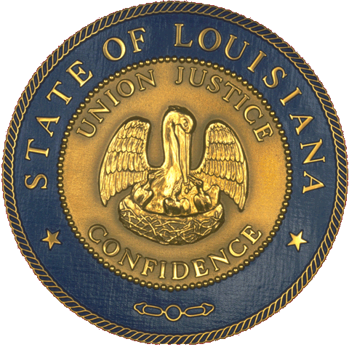

**State of Louisiana**

Office of the   
Lieutenant Governor

Department of Culture, Recreation, Tourism

Office of   
Cultural Development

**Louisiana State Arts Council**

**Quarterly Meeting Minutes**

**Capitol Park Welcome Center**

**Monday, August 25, 2014**

**Council Members present:** Chairman Michael Echols, Rex Alexander, Jacques Rodrigue, Michael Robinson, Gena Gore, Dwayne Carruth, Mary Lee, Kirk Talbot, Pat Widhalm, and Missy Crews.

**Council Members not present:** Pam Breaux, Gerri Hobdy, Patti Nelson, Waynette Ballengee, Karen Sharp, Barbara Motley, Marguerite Anderson, Sheela Plater, and George Marks.

**LDOA Staff present:** Cathy Hernandez, Dana La Fonta, Gaye Hamilton, Paula White and Maida Owens

**I. Call to Order and Welcome**

The meeting was called to order at 10:34 a.m. by Chairman Echols.

**II. Approval of Minutes**

The July 16, 2014 minutes were approved upon motion by Gena Gore, which was seconded by Mary Lee, and unanimously passed by the Council.

**III. Chairman’s Reports**

Michael kept his report brief by telling everyone that we were doing a great job. He mentioned that we would skip ahead to the grant report.

**IV. LDOA Staff Reports**

**Grant-making:** Paula White presented the proposed FY15 Grant Awards for the Plan Review Grant.  These FY15 Grant Awards were approved upon motion by Gena Gore, which were seconded by Pat Widhalm, and unanimously passed by the Council.  Gena Gore, LSAC Liaison for the Grants Program, and Paula White spoke about the Regional Development Agencies (RDAs) Plan Review Grant.  This grant is only available to the 8 RDAs.  The grant allocations are as follows:

|  |
| --- |
| Shreveport Regional Arts Council / Region 7 $64,500 |
| Acadiana Center for the Arts / Region 4 $49,423 |  |
| Arts Council of New Orleans / Region 1 $51,250 |  |
| Arts & Humanities Council of SW LA / Region 5 $14,400 |  |
| NE LA Arts Council / Region 8 $14,538 |  |
| Arts Council of Baton Rouge / Region 2 $46,401 |  |
| St. Tammany Parish / Region 9 $14,537 |  |
| Arts Council of Central LA / Region 6 $12,000 |  |

**V. New Business**

No other reports were made, as all grants were ratified.

**VI. Public Comment**

Cathy Hernandez mentioned that this would be the last meeting of the year. A 2015 schedule of meetings would be made available at the beginning of the year.

**VII. Adjournment**

The meeting was adjourned at 11:20 a.m. upon motion of Gena Gore, which was seconded by Rex Alexander, and unanimously passed by the Council.